Software Requirements Specification

Version 1.0

October 22, 2016

**Campus Tour Software**

**Crazy Coders**

Chitturi, Rakesh

Dande, Mallikharjuna Rao

Kotu, Chiranjeevi Sneha

Parimi, Teja

Prodduturi, Nayan Reddy

Solasa, Vamsi Krishna

Submitted in partial fulfillment

Of the requirements of

CSIS44-691 Graduate Directed Project 1

Table of Contents

Table of Contents i

List of Figures ii

1.0. Introduction 1

2.0. Overall Description 4

2.1 System Environment 4

2.2 Functional Requirements Specification 5

2.3 User Characteristics 15

2.4 Non-Functional Requirements 15

3.0. Requirements Specification 17

3.1 External Interface Requirements 17

3.2 Functional Requirements 17

3.3 Detailed Non-Functional Requirements 23

3.3.1 Security 25

Index 26

List of Figures

Figure 1 - System Environment 4

Figure 2 - Article Submission Process 6

Figure 3 - Editor Use Cases 8

Figure 4 - Logical Structure of the Article Manager Data 23

# 1.0. Introduction

## 1.1. Purpose

The purpose of this document is to present a detailed description of the Campus tour software. It will explain the purpose and features of the system, the interfaces of the system, what the system will do, the constraints under which it must operate and how the system will react to user input. This document is intended for both the stakeholders and the developers of the system and will be proposed to the client for approval.

## 1.2. Scope of Project

This will be a mobile application for users the campuses which are enrolled to the application (enrollment procedures will be explained in detail in the latter part of this document). This application will be designed to maximize productivity by aiding users to take a tour of the campus of universities which would otherwise be a tedious task. By understanding the users need this application will be productive and useful to the users.

The audience will be the prospective students or their parents who want to get familiar with the infrastructure and the facilities provided at different locations in the university. This application is designed to allow the user to scan the QR Code of the building and get to know the details of the buildings on the campus and to keep a track of the buildings visited with the help of a map using GPS. This software will facilitate communication between users GPS and campus buildings.

## 1.3. Glossary

|  |  |
| --- | --- |
| **Term** | **Definition** |
|  |  |
|  |  |
|  |  |
|  |  |
|  |  |
|  |  |
|  |  |
|  |  |
|  |  |
|  |  |
|  |  |
|  |  |
|  |  |

## 1.4. References

IEEE. *IEEE Std 830-1998 IEEE Recommended Practice for Software Requirements Specifications.* IEEE Computer Society, 1998.

## 1.5. Overview of Document

The next chapter, the Overall Description section, of this document gives an overview of the functionality of the product. It describes the informal requirements and is used to establish a context for the technical requirements specified in the next chapter.

The third chapter, Requirements Specification section, of this document is written primarily for the developers and describes in technical terms the details of the functionality of the product.

Both sections of the document describe the same software product in its entirety, but are intended for different audiences and thus use different language.

# 2.0. Overall Description

## 2.1 System Environment

The system is the campus tour application running on the Android Smart phone.

Our Assumptions about the client environment include

1. Internet connection
2. GPS functionality
3. Compatible with Google Maps application

Figure 1 - System Environment

The purpose of the application is to give a campus tour of University selected by the user.

## 2.2 Functional Requirements Specification

This section outlines the use cases for each of the active users separately.

**2.2.1 Application Home Screen:**

Upon launching the application from the applications list the app throws a prompt to select a university campus, once a university is selected the application connects to the database, downloads the campus related information and loads the map with the university’s location.

**Initial Step-By-Step Description**

1. Clicks on the application
2. Application launches with main page showing to select a campus.
3. User selects a campus and the application. This is a mandatory step and user cannot proceed without selecting any campus a popup will be thrown to alert and make the user to complete this step.
4. Once the user selects a campus the application connects to the database and downloads the campus related data. If connection fails, the user is alerted of failure and suggests to try again later.
5. Once the download is complete the application opens a map and loads the map with the campus location downloaded from the database.

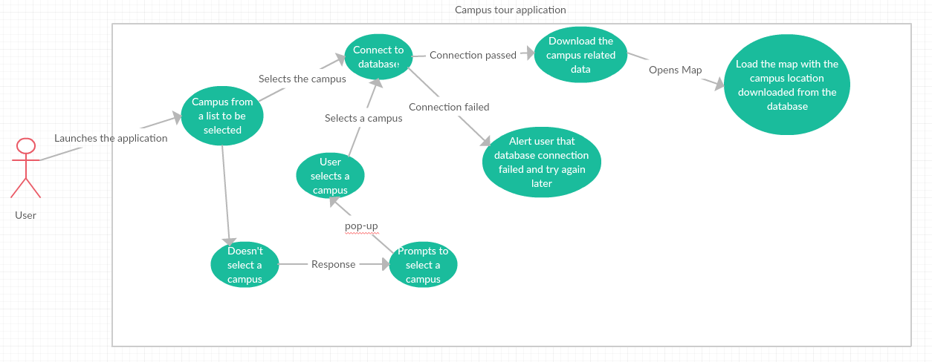

### **The Campus Tour**

**Brief Description:** Once the user is on the home screen he has two options, one to start a campus tour, and another to start a virtual tour.

1. Virtual tour – has limited functionality. Shows the key point of interest pre-determined by the campus database administrator and, displays the data taken from the database for each point of interest.
2. Campus tour – Can be done only when user is on campus and it has many features like audio assist, QR is scanning elements, Interactive map and path taken.

**2.2.2 a) Virtual Tour**

**Step-By-Step Description**

1. The user enters the home screen
2. Two buttons are shown
3. Clicks on Virtual tour
4. Application loads the map, Zooms out to campus overview
5. Campus overview shows all marked buildings downloaded in first step (Pre-determined and loaded into database by the database administrator)
6. User can click on POI to view its details.
7. Clicks on end tour to come back to the main home page in step 1.

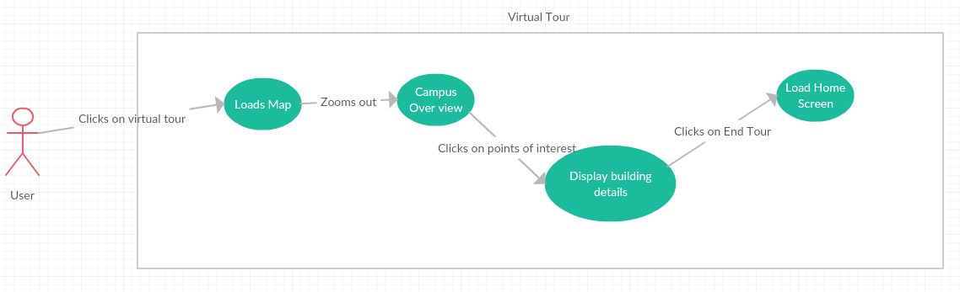

#### b) Campus Tour

**Step-By-Step Description**

1. User enters the home screen.
2. Two buttons are shown.
3. Clicks on Campus Tour.
4. The application gets the user location from the location services and opens the map and marks the current location of the user.
5. The path is pre-determined (DBA sets it and app downloads it in the beginning) and the app starts the tour from nearest location from the user.
6. When the user approaches a building the application gives audio feedback on where he/she is and gives audio feedback on the nearest building in the path and directs to its QR code location.
7. Once user scans the QR code the app displays the information of the building and if it finds any audio and video data on the building it displays them too.

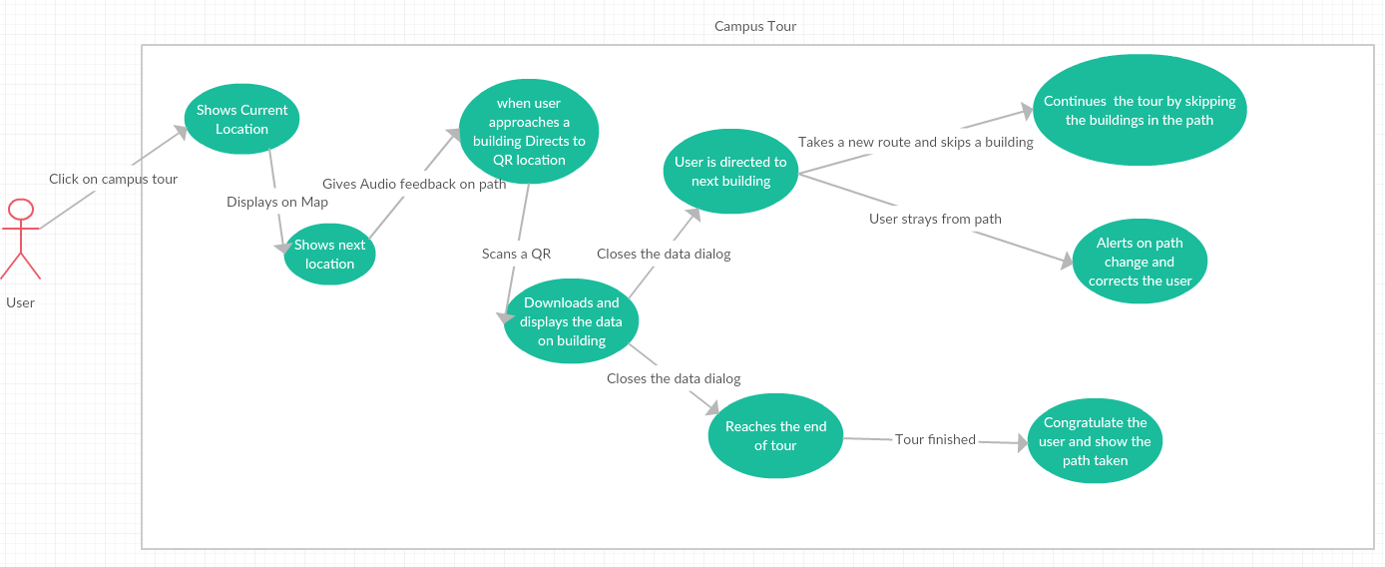

**Brief Description**

This use case describes about the error flow in the application. When the user disconnects from the network or goes away from the given direction.

**Initial Step-By-Step Description**

1. The user goes away from the path.
2. Alert the user about the path change.
3. After alerting the user the application gives the user the correct directions to the path.
4. When the user is in the correct direction as shown in the map the tour is resumed.
5. The second scenario is when the user disconnects from the network.
6. The application notifies the user when he is disconnected from the network asking him/her to connect to the network.
7. The application prompts the user to enable data.
8. After the user enables the data the application resumes with the campus tour.

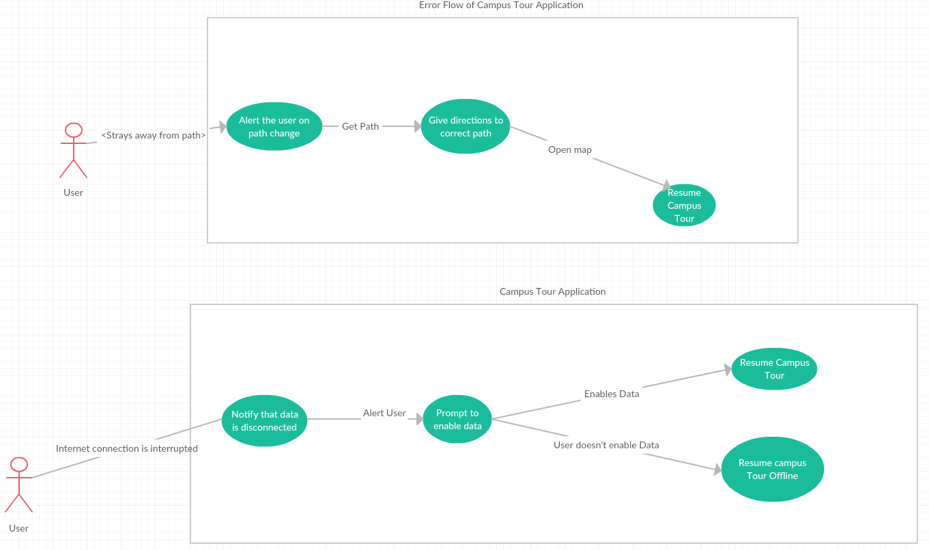

#### Use case: Error Flow of Campus Tour

**2.2.4 QR Scan Use Case**

**Brief Description**

This use case describes about the QR Scan code. This gives a detailed description of how the user will scan the QR code and the functionality of this feature.

**Initial Step-By-Step Description**

1. User approaches a QR code
2. Launces the QR camera from side menu options
3. Scans the QR code
4. Application processes the QR code
5. Launches the activity corresponding to the QR code
6. During the initial step when user selects a campus the app downloads the pictures and text data of all buildings in this step it downloads any video or audio data for this building and shows the result in a window
7. If QR scanned is invalid the app prompts the user to scan in once again
8. Even for the second try the QR scanned is invalid then the app prompts to close the application and open it again to fix the issue.
9. If Any audio data is present and if the user clicks in read out loud button the app reads out the audio information
10. If any video data is present, the user can view it by clicking on the video
11. On the other hand, if no data is found a tag is displayed with message <No data present for this building>.

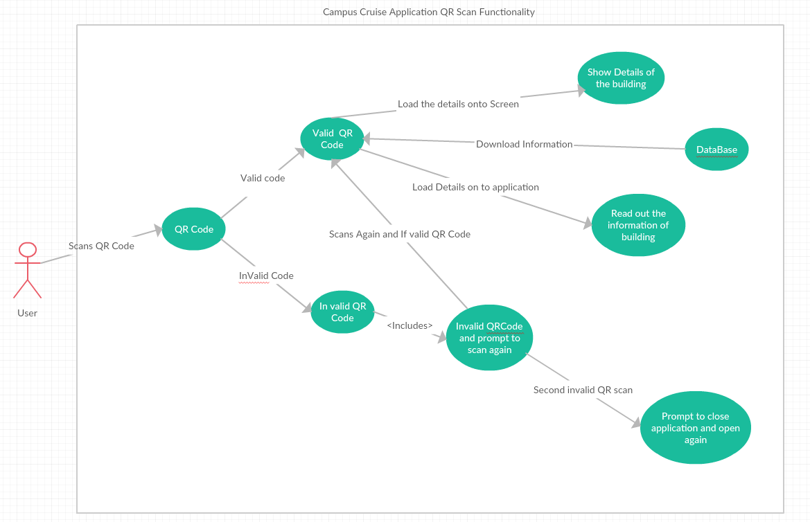

**Use case: QR Scan Functionality**

### **2.2.5 Approaching Building Use Case**

#### 

#### Use case: Approaching building Use case

**Diagram:**

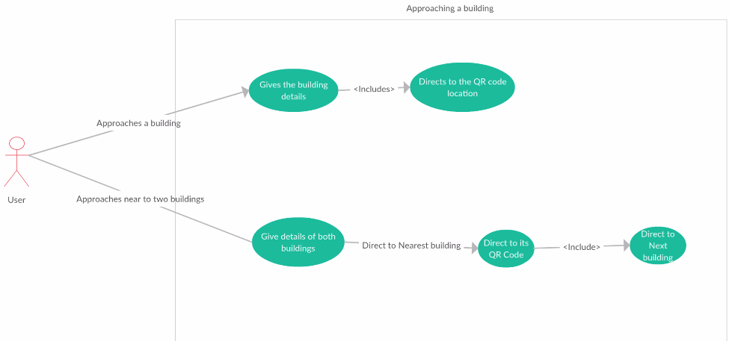

**Brief Description**

**Initial Step-By-Step Description**

1. User approaches a building, the app issues audio information saying that the user is nearing a building, tells in which direction the building is and directs to the QR code location of the building.
2. User approaches two buildings, Application senses the borders of two buildings
3. Issues audio information of approaching buildings
4. Directs to the nearest building and once user finishes viewing the building direct to next building.

**2.2.6 Offline Tour**

**Brief Description**

This use case describes about the Offline Tour, When user has internet or GPS dis connectivity the app senses it and in case user is unable to restore the connection the application goes to offline mode. In offline mode, the tour is reduced to key point of interests only and doesn’t have the audio and video feedbacks.

**Initial Step-By-Step Description**

1. App loses the connection to internet
2. App prompts the user to connect to data
3. If step 2 fails convert to offline mode
4. In offline mode show only the key points of interest. NO QR scan functionality in case of internet connection failure.
5. When user clicks on a building app shows building details.
6. When user clicks on end tour it takes the user back to home screen showing the over view of campus map.

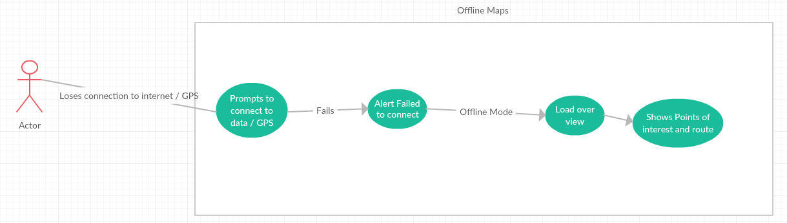

## 2.3 User Characteristics

**Application User –** End user of the app.

**Database Administrator – Super User** – Adds Universities to the Database and defines a university database administrator for it.

**Database Administrator University user –** Adds, updates or removes what the application user views. Has access to the interface of database to change the data. Has access to only assigned university’s data.

# 3.0. Requirements Specification

## 3.1 External Interface Requirements

## 3.2 Functional Requirements

## The Application should provide a Campus tour for universities whose details will be fetched from a database.

## The application should show the campus map and all the buildings and parking lots in and around the campus.

## The application should allow users to track their path taken over the course of tour.

## The application should be able to provide a virtual tour of the campus to the user.

## The application should be able to scan the QR Code placed on the building to retrieve and display the information from database.

## The application should be able to detect the internet connectivity

## If there is no internet connection should display connect to Internet.

## If there is internet, then proceed with the tour.

## If GPS goes off in the middle, then along with the message should display go to any nearest building to start the tour.

## If GPS is on and the user is not near to the campus map, then it should show a message to ask the user to go the nearest building.

## If the user is not in the range of the selected campus, to start the campus tour application intimates user to go near the university in order to start the campus tour. In case of the virtual tour the app should not ask to go to the campus.

## QR Code placed outside the building, and GPS are to be used to capture the user’s movements around the campus during the tour.

## There should be a database for every University campus for the Data to be displayed in the application.

## There should be an interface for an admin to add universities and define Data Base Administrator (DBA) for each university.

## Each university has an interface for its DBA who adds, updates or removes building data and other seasonal events, the events which app shows to the user when QR is scanned. DBAs would have access only to their assigned university data.

## The application should show the orientation of the map and should have the option to view the map in fixed north (i.e., the map rotated with user movements) or fixed map (the user rotates but map stays static) setting

## 3.3 Detailed Non-Functional Requirements

### 3.3.1 Logical Structure of the Data

* Campus stays on the top of the hierarchy
* Under campuses comes the buildings
* Each building has text, audio and video data. (Can have no data too)

### 3.3.2 Security

### Privileges to add or update events and building data should be available to only respective university DBA and should be well protected using a variety of security measures

# Index

Abstract, 6, 17, 27

add, 9, 11, 19, 20, 21

Add, 8, 9, 19

Article, 1, 5, 6, 7, 8, 9, 10, 11, 12, 13, 14, 15, 16, 17, 18, 19, 20, 21, 22, 23, 24, 25, 26, 27, 28

Article Manager, 5, 8, 9, 10, 11, 12, 13, 14, 15, 16, 19, 20, 21, 22, 23, 24, 25, 28

Author, 1, 4, 5, 6, 7, 8, 9, 13, 14, 16, 17, 19, 20, 22, 23, 25, 26, 27

Category, 5, 14, 17, 18, 20, 21, 23, 26, 27

Database, 2, 9, 11, 14, 15, 16, 17, 18, 19, 20, 21, 22, 24, 25, 26, 27

Editor, 1, 4, 5, 6, 7, 8, 9, 10, 11, 12, 13, 14, 15, 16, 17, 19, 20, 21, 22, 23, 24, 25, 28

Field, 17, 19, 20

Form, 1, 6, 9, 10, 11, 12, 14, 19, 20, 21, 23, 24, 27

Grid, 9, 11, 12, 19, 20, 21

Historical Society, 1, 5, 9, 11, 16, 17, 19, 20, 26

Online Journal, 4, 5, 6, 7, 15, 16, 17, 18, 24, 27, 28

Reader, 4, 5, 6, 16, 17, 18

Review, 1, 7, 11, 12, 18, 21, 23, 26, 27

Reviewer, 1, 4, 5, 6, 7, 9, 11, 16, 17, 19, 20, 21, 22, 23, 26, 27

Security, 27, 28

Status, 11, 12, 13, 14, 17, 21, 22, 23, 27

update, 9, 11, 20, 21

Update, 8, 9, 10, 11, 12, 13, 14, 15, 17, 19, 20, 21, 22

User, 7, 16, 18

Web Publishing System, 1, 4, 5, 17